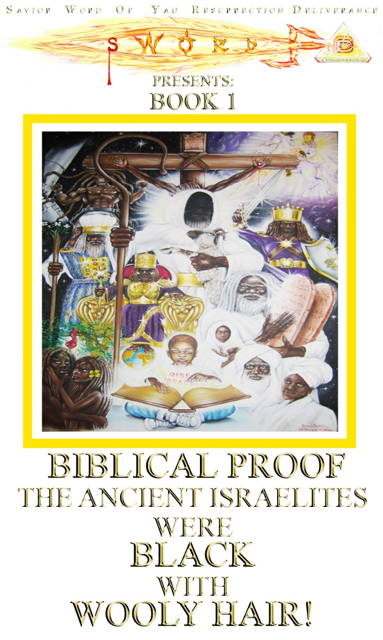

THE WORD OF YAH
(The Beginning and the End)

YAH’S WORD IN THE BEGINNING!
John 1:1 In the BEGINNING was THE WORD, and THE WORD was with Elohim, and THE WORD was Elohim.
WORD BECAME FLESH!
John 1:14 And THE WORD was made FLESH (The True Biblical Black Hebrew SAVIOR).
WHY?
John 1:29 The next day John saw Yahshua coming unto him, and saith, Behold the Lamb of Yah, which taketh away the SIN of the world.
ISRAEL REJECTED THE WORD!
John 1:11-12 He (THE WORD) came unto HIS OWN (Black Nation of Israel), and HIS OWN (Black Israel) received Him (THE WORD) NOT.
But as many as received Him (THE WORD), to them gave He POWER (HOLY SPIRIT!) to become the SONS OF YAH, even them that believe on HIS NAME.

YAH’S WORD IN THE END!
Rev. 19:13 … And he was clothed with a vesture dipped in blood (the LAMB OF YAH): and HIS NAME IS CALLED… THE WORD OF YAH!

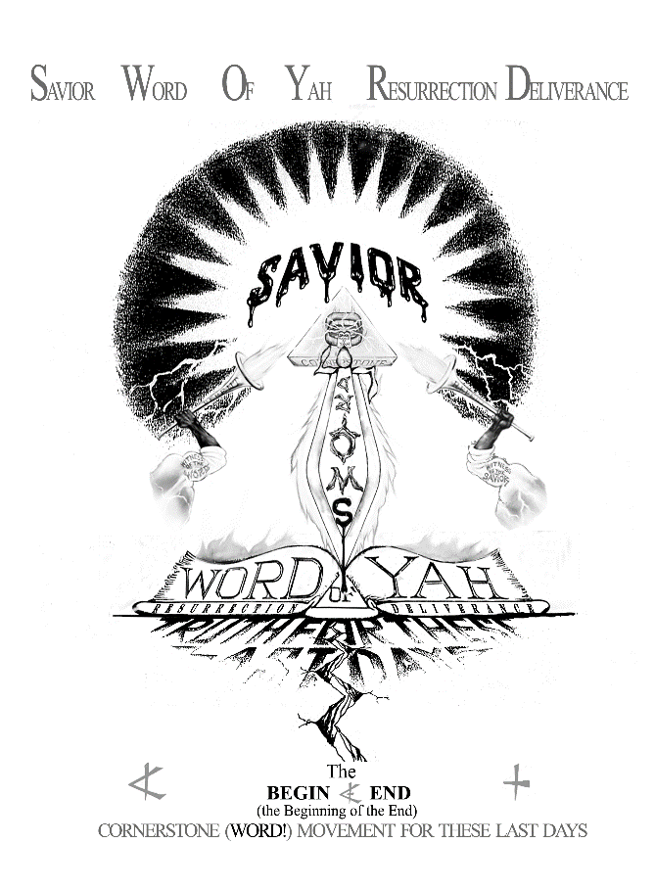

Introduction

Scriptures teach “Satan would DECEIVE the WHOLE WORLD!” Today the whole world has been the victim of a WORLD WIDE CONSPIRACY on behalf of the Euro-Gentile powers to totally WHITE WASH HISTORY.
History records one of its darkest days when, in 70 A.D., the mighty Roman Empire crushed the ancient African Hebrew Nation of Israel. The survivors were scattered into captivity among all Nations, most fleeing into Africa. With her most brilliant light now extinguished, Africa slipped into her long night of darkness. But what History didn’t record is an even greater victory wrought by the mighty PEN (the pen is mightier than the sword), which has conquered the whole world.
This same Euro-Roman Empire commissioned such artists as Michelangelo, Leonardo DaVinci, etc. to paint the ancient Hebrew prophets Abraham Moses, King David, King Solomon, and even the blasphemy of painting the Messiah Himself, as European. Today through paintings, sculpture, television, and movies, etc. he has succeeded in conquering the MINDS of the whole world into believing the GREAT EUROPEAN LIE, that the Messiah and His people (the ancient Israelites) were WHITE!
Today the whole world has been DECEIVED! They assume without proof that the Jews of the Bible were and are, white. These and many other groups of Europeans try vainly to claim descent from the lost ancient tribes of Israel based on their own false paintings, tradition, customs, wealth, etc. However the only true standard we should accept as TRUTH concerning the PROOF of the racial origins of the ancient prophets and Hebrew Israelite Nation of the Bible, are those FACTS revealed in the Holy Bible (the Creator’s WORD!)
What then is the TRUTH? What are the biblical SIGNS YAH has left the world in His HOLY WORD concerning the KNOWLEDGE of who today, of all nations, qualifies to claim descent from the ancient Hebrew Israelites? The TRUTH might astound you.
In this writing we will explore the bible and extract the facts to present to our readers, so we can be informed as to what the Bible really teaches concerning the racial origin of the true Jews. It’s time the world “KNOWS THE TRUTH!”

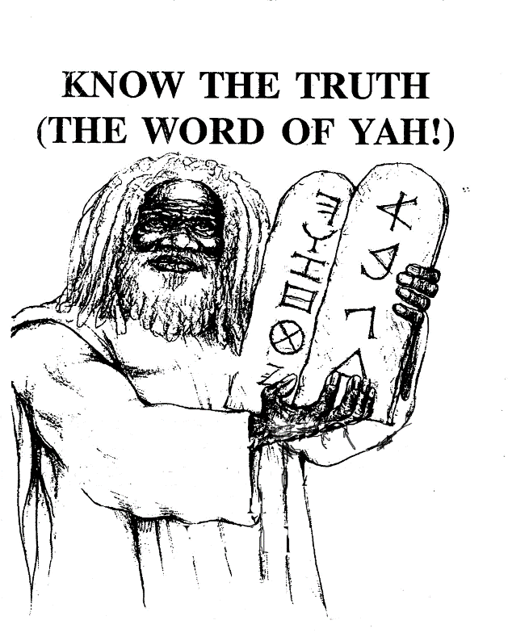

PART 1
THE ANCIENT ISRAELITES
WERE BLACK WITH WOOLY HAIR!
This chapter contains the Biblical Proof that all the prophets of the Bible: Adam, Noah, Abraham, Isaac, Jacob, Moses, King David, King Solomon, and even SAVIOR (THE WORD MADE FLESH) were all so called BLACKS with WOOLY HAIR!
The WORD said: ... “KNOW THE TRUTH (THE WORD OF YAH! John 17:17) and the TRUTH (THE WORD!) shall make you FREE!” John 8:32
WORD KNOWLEDGE!
My People (the ancient Israelites: today the SO-CALLED NEGROES) are DESTROYED for a…. LACK OF KNOWLEDGE. Hosea 4:6
PROOF!
PROVE ALL THINGS; hold fast that which is good. I Thessalonians 5:21
THINK!!!
The (dumb) ox knoweth his owner, and the (dumb) ass his master’s crib: but Israel DOETH NOT KNOW, My People DOTH NOT CONSIDER. (We don’t….THINK!) Isaiah 1:3
BIBLICAL PROOF
The three introductory scriptures on the preceding pages (Hosea 4:6, 1 Thessalonians 5:21, and Isaiah 1:3) will form the basic premise for the information presented in this work.
Despite our being the most religious, church going people on the face of the earth, the Bible describes us as a people DESTROYED for a lack of KNOWLEDGE! Sad to say we go to church religiously but in general remain completely ignorant to what is actually written in His SAVING WORD.

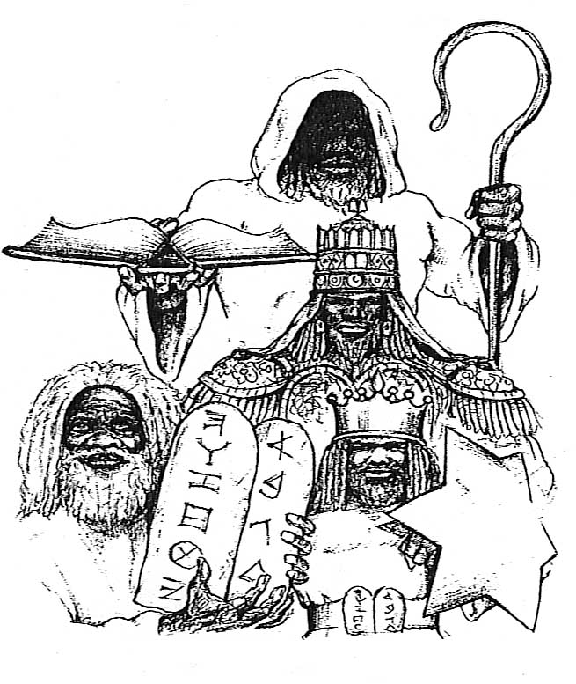

Being ignorant of HIS WORD, we have been taught to just believe. We have been taught to believe in things we have no knowledge or understanding of, in what amounts to outright LIES and DECEPTIONS! We as a people have been duped into believing in any and everything. But, contrary to this BLIND FAITH the Word teaches us to “PROVE ALL THINGS and (only) hold unto that which is (proven) GOOD (or TRUE!).”
Finally the scriptures teach that we as a people simply DON’T THINK! Not that we can’t think, but we simply choose not to think, finding it more comfortable to let others (often or enemies) think for us.
Here then is the BIBLICAL KNOWLEDGE that will PROVE beyond a shadow of a doubt that the ancient Israelites were so called BLACKS with WOOLY HAIR! All you have to do is carefully read the material and … THINK!
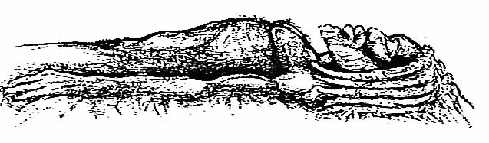
KNOWLEDGE
The first man, Adam, was a man of color (NOT WHITE).
BIBLICAL PROOF
Genesis 2:7 YAH Elohim formed MAN (Adam) from the dust of the GROUND.
The GROUND is NOT WHITE…

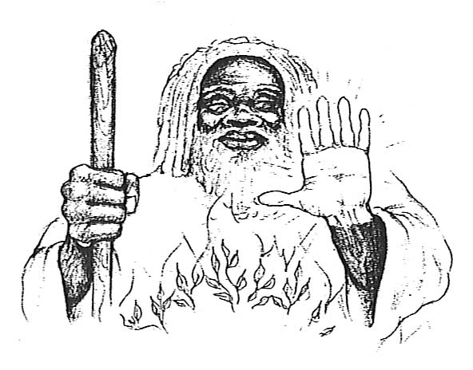

MOSES was of a DARK RACE.

Exodus 4:6, 7 And YAH said furthermore unto him (Moses), put thine Hand into thy bosom. And he put his hand into his bosom: and when he took it out, behold, his HAND was LEPROUS AS SNOW (WHITE!).

And he said. Put thine hand into thy bosom again. And he put his HAND into his bosom, and, behold, it was turned again as his OTHER FLESH (of COLOR).

In the movie the Ten Commandments they showed Charleston Heston’s staff turning into a serpent, but left out his hand turning white. Why? Because his hand was already white.

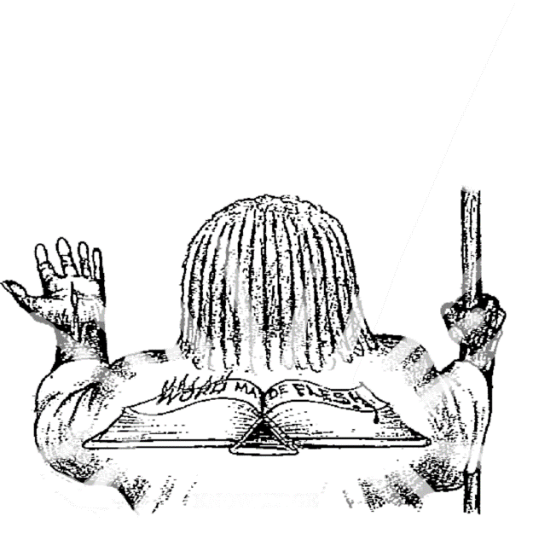

The Messiah Yahshua (WORD made FLESH) was BLACK, with WOOLY HAIR.

Revelation 1:14, 15 His head and His HAIRS were white LIKE WOOL (WOOLY!).

And His FEET (flesh) like unto FINE BRASS, as if they BURNED in a furnace;

Is BURNED BRASS WHITE? You can’t get brass color without the color Brown.

Is WOOLLY HAIR BLONDE and SILKY?
…(THINK!)

Ethiopian Jews
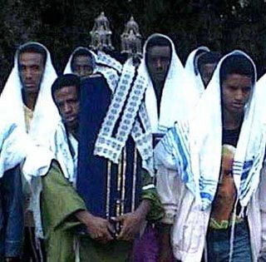

YAH described His People, Ancient Israel as the Ethiopians (BLACK AFRICAN NATION).

BIBLICAL PROOF
Amos 9:7 Are ye not as children of the Ethiopian (BLACK NATION) unto Me, O children of Israel? Saith YAH. Have not I brought up (BLACK) Israel out of the land of (BLACK) Egypt?
Jeremiah 13:23: Can the (BLACK) Ethiopian change SKIN, or the leopard his spots? NO!
Can a people that were BLACK in ancient times, turn WHITE today? ... (THINK!)

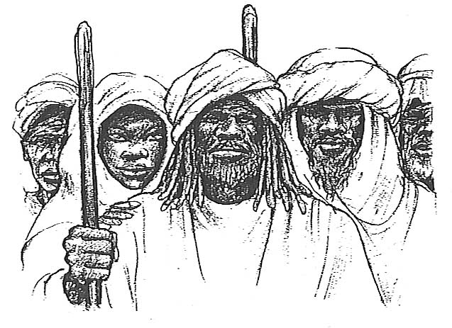

The BIBLICAL HEBREWS’ faces were always described as looking black not gray, or pale, or ghostly white.

BIBLICAL PROOF
Job 30:30 My skin is black upon me
Lamentations 4:8 Their visage (to look upon) is BLACKER than a coal;
Nahum 2:10: and the FACES of them ALL GATHER BLACKNESS.
Can the faces of all so-called JeWish people gather blackness?
…(THINK!!!!)

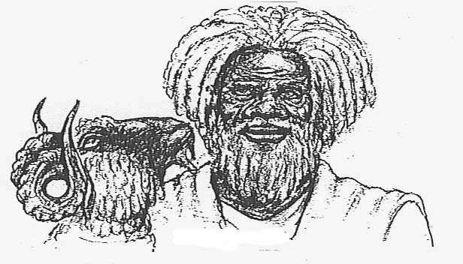
LAMB

WOOLY HEAD
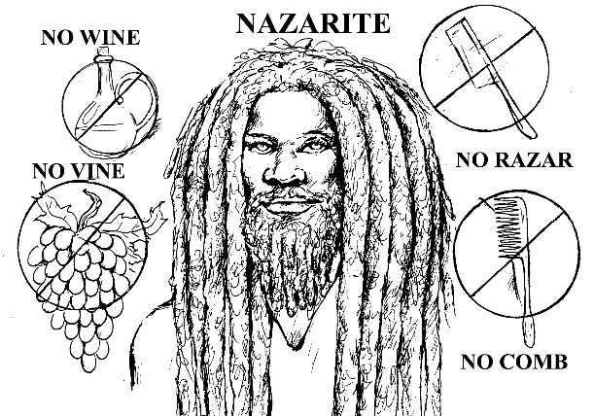

HEBREW
The ANCIENT BLACK ISRAELITES are described as having WOOLY HAIR, just like their Almighty SPIRITUAL FATHER YAH (the Ancient of Days). The Bible teaches the ancients wore their HAIR in shoulder length, WOOLY LOCKS, called today… DREAD LOCKS or LOCKS!!!

BIBLICAL PROOF
Daniel 7:9 I beheld ill the thrones were cast down and the Ancient of Days did sit, whose garment was white as snow and the HAIR of His Head like the PURE WOOL.
Numbers 6:5 All the days of the vow of his separation there shall NO RAZOR come upon his HEAD: until the days be fulfilled, in which he separateth himself unto YAH, he shall be HOLY, and shall let the Locks (called today dread locks) of the HAIR of his HEAD GROW.
Ezekiel 44:20 Neither shall they (priests) SHAVE their HEADS (NOT TOO SHORT) nor suffer their Locks to Grow Long (NOT TOO LONG) they shall only POLL (trim) their heads. Who has WOOLY HAIR? …(THINK!)
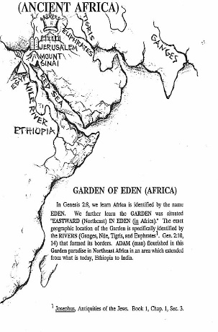
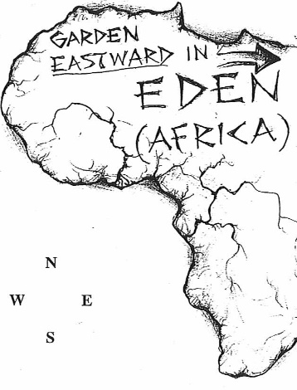

(Africa is Eden)

FIRST WORLD, peoples of color, have been the victims of a worldwide conspiracy to erase all knowledge of their glorious contribution to the building of civilization. Most of the ancient nations we read about in the Bible were NON-WHITE, DARK SKINNED nations of color. Israel, Egypt, Ethiopia, Babylon, Assyria, Arabia, Philistine, etc. were all great black Semitic and Hamitic nations. The truth is that the Greeks under Alexander the so called Great was the first European nation to enter civilization.
We have to reclaim our great and glorious past. In the Bible, AFRICA is called EDEN. This fact is borne out by the description of the Garden YAH Elohim planted EASTWARD (Northeast) in EDEN (in Africa); YAH Elohim gave the location of the Garden of Eden by NAMING the rivers which forms its boundaries. Much of this same area was given to the SEED for Abraham, for the future inheritance in the Kingdom of YAH.

BIBLICAL PROOF
Genesis 2:8: – 10,14 And YAH Elohim planted a Garden EASTWARD… IN EDEN (in Africa); and there (Eastward in Africa) He put the MAN (Adam) whom He had formed. And the river went out of Eden (Africa) to water the garden; and from thence it was parted, and became four heads.
The name of the first is Pison (Greek name Ganges): that is it which compasseth the whole land of Avila (India), where there is gold; and the gold of that land is good; there is bdellium and the onyx stone
And the name of the second river is Gihon (Greek name Nile): the same is it that compasseth the whole land of Ethiopia.
And the name of the third river is Hiddekel (Greek name Tigris) that is it which goeth toward the east of Assyria. And the fourth river is Euphrates.

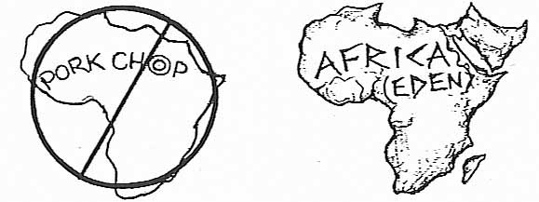
Genesis 15,18 In the same day YAH made a COVENANT with Abram saying, unto thy SEED

(children) have I given this land, from the RIVER OF EGYPT (Nile) unto the great river, the river of EUPHRATES:

To accept a Map of Africa which bases its Northeastern border on the manmade Suez Canal(Zeus spelled backwards), and not on the Euphrates river is to allow the European conspirators erase 4,000 years of our great BLACK HISTORY.

The BIBLE is basically an AFRICAN BOOK, about black African Semitic and Hamitic Peoples. For example, the European nations of Greece and Rome together are mentioned only four times in the entire Old Testament, compared to African Nations such as Egypt, Ethiopia, Babylon, Canaan, etc. which are mentioned well over a thousand times.
BIBLICAL PROOF
Genesis 12:10 And there was a famine in the land : and Abram went down into Egypt (Africa) to sojourn there;

Genesis 46;2,3 And Elohim spake unto Israel in the visions in the visions of the night, and said, Jacob, Jacob. And he said, Here I am
And He said I am El, the El of thy father: fear not to go down into Egypt: for I will there make of thee a GREAT NATION: (in Africa).
Can you ever remember reading in the Old Testament of the Bible, OUR TRUE BLACK HISTORY BOOK, of our forefathers going into a European country?

The European interpreters of the Bible would have you to believe that SNOW WHITE Israelites went down into BLACK Egypt, and came out after 430 years with a mixed multitude (other African nations), which went into BLACK Canaan (Son if Ham, Genesis 10:6) land, where they intermarried, but still remain SNOW WHITE today (THINK!)
KNOWLEDGE
Despite European attempts to WHITE WASH history, there exists too much overwhelming evidence in the form of HIEROGLYPHICS, STATUES, and RELICS which shows Egypt as one of the principal BLACK NATIONS of the ancient world.
BIBLICAL PROOF
Genesis 42:6-8 And Joseph was the governor over the land (Egypt) and he it was that sold to all the people of the land: and Joseph’s brethren came and bowed themselves before him with their faces to the earth. And Joseph knew his brethren, but they knew (recognized) him not.
Don’t you think if Joseph was WHITE, his WHITE brothers would have suspected him of being their brother in a BLACK EGYPT. (THINK!)

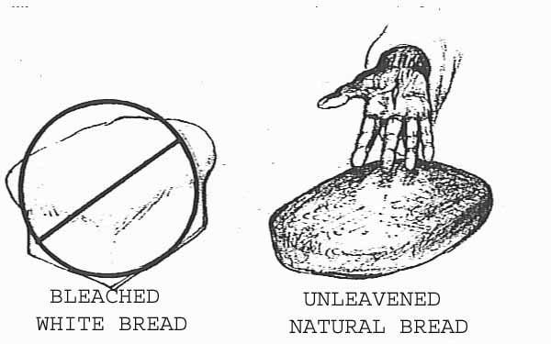

The Messiah left us a SIGN he was of color (NOT WHITE)

BIBLICAL PROOF

Luke 22:17 And He took bread, and gave thanks, and brake it, and gave unto them saying, This is (Symbolically) MY BODY which is given for you: this do in remembrance of Me.

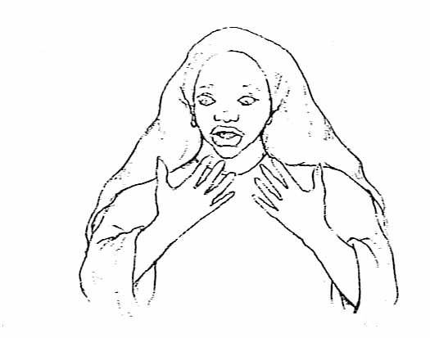
Natural wheat bread is BROWN (of color) like the good earth. Yahshua the Messiah didn’t bless and break a piece of ARTIFICIALLY BLEACHED WHITE BREAD. Why do they bleach bread?

CURSED (WHITE!)
KNOWLEDGE
The world has been BRAINWASHED by European whites to think that snow white was beautiful but according to the bible the WORD of YAH, Moses’ sister Miriam was cursed… and became LEPEROUS WHITE AS SNOW, and Aaron described her as one of the DEAD!
BIBLICAL PROOF
Numbers 12:10-12 And the cloud departed from off the tabernacle; and behold, Miriam became LEPROUS, WHITE AS SNOW: and Aaron looked upon Miriam, and, behold, she was LEPROUS.
Let her not be as on DEAD, of whom the FLESH is half consumed when he cometh out of his mother’s womb.
No wonder SUN TANNING lotion is a multi-billion dollar industry. (THINK!)
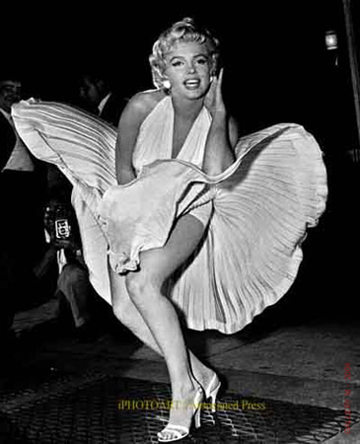

We have been taught that to be BLACK was a CURSE, but on the contrary the Holy Bible reveals that to turn WHITE with YELLOW HAIR was a CURSE!
BIBLICAL PROOF
Leviticus 13:9, 11-23, 30 When the PLAGUE OF LEPROSY is in a man, then he shall be brought unto a priest;
And the priest shall see him: and, behold, if the rising be WHITE in the SKIN, and it have turned the hair white, and there be quick raw flesh in the rising.
It is an OLD LEPROSY in the SKIN of his FLESH, and the priest shall pronounce him UNCLEAN, and shall not shut him up: for he is UNCLEAN. (THINK!)
If a man or woman have a plague upon the HEAD or BEARD: then the priest shall see the plague: and, behold, if it be in sight deeper than the skin; and there be in it a YELLOW THIN HAIR (BLOND!); then the priest shall pronounce him UNCLEAN: it is a dry scall, even a leprosy upon the HEAD or BEARD.
NOTE: Leviticus13: 12, 13; And if a LEPROSY break out abroad in the SKIN, and the leprosy cover ALL THE SKIN of him that hath the PLAGUE from his HEAD even to his FEET, wheresoever the priest looketh;

Then the priest shall consider: and, behold, if the LEPROSY have COVERED ALL HIS FLESH, he shall pronounce him CLEAN that hath the PLAGUE: it is ALL TURNED WHITE: he is CLEAN.

Would YAH give LAWS against TURNING WHITE to a WHITE PEOPLE? Or would the Messiah (Savior [Word] of YAH), when he was here in the FLESH, be SNOW WHITE with BLOND (YELLOW) STRINGY HAIR as pictured in PAINTINGS, MOVIES and BOOKS?
(THINK!)…(THINK!)…(THINK!)

PART II

SECULAR KNOWLEDGE

So far we have only covered the overwhelming evidence YAH has left in His WORD (the HOLY BIBLE), concerning PROOF that the Ancient Hebrew Israelites were a dark skinned, wooly haired people, including Yahshua the Messiah.
These facts, however are not confined exclusively to the Bible. There also exists much PROOF in SECULAR HISTORY, ART, SCIENCE ARCHEOLOGY, etc, which we cannot overlook.

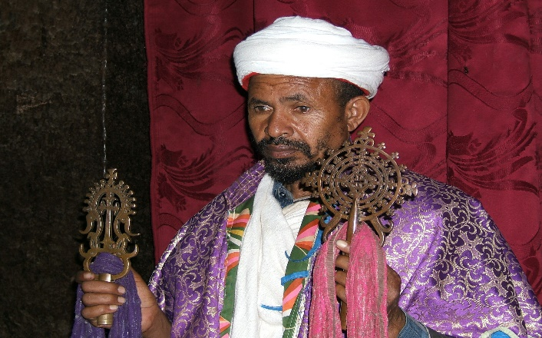

THE BLACK JEWS OF ETHIOPIA
The oldest Israelite community in existence today is BETA ISRAEL of Ethiopia, commonly known as the BLACK (Falasha) JEWS of Ethiopia. These Black Jews possess an UNBROKEN History tracing back some 3,000 years to the time when King Solomon sent their forefathers with his son Menelek, to the Queen of Sheba (Ethiopia) in 10th century B.C. This community predates the earliest European Jewish CONVERTS (not of the SEED of Israel) over some 1,700 years.
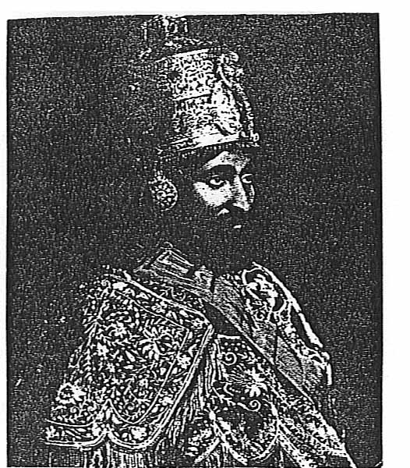
How can there exist in the world today two opposing sets of people, one WHITE with STRAIGHT HAIR and other BLACK with WOOLY HAIR, who both claim to be the children of Israel? One of them is obviously a LIAR (an IMPOSTER). (THINK!
HAILE SELASSIE, SON OF DAVID
The Emperor Haile Selassie the First, is the only monarch of modern times, who could boast that he was a direct descendent of KING DAVID through the dynasty of Menelek the First. Menelek was born of the union of Kin Solomon (of Israel), the son of King David, and the Queen of Sheba (of Ethiopia). This dynasty was perpetuated without interruption from that ancient time. By the way, Emperor Haile Selassie was a BLACK MAN with WOOLY HAIR.

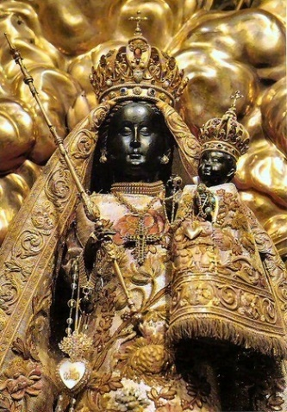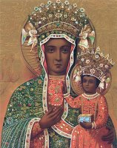
BLACK MADONNA AND CHILD

It is known fact that there exists, in many of the early Roman churches throughout Europe, shrines dedicated to early paintings depicting the Madonna and Child as DARK SKINNED with drapery white eyes. It was not until later that these early paintings were replaced by more contemporary European depictions. These older paintings of the Black Madonna and Child were retired to more remote areas of the church but were not destroyed and can still be found there. The cases of these Black Madonna’s are too numerous to list in this work, but J.A. Rogers devotes a whole chapter to that study in his book, Sex and Race, Volume 1 (page 273).
Would Europeans of the early Roman Church period depict the Madonna and Child as BLACK, unless it was the consensus of the ancient world that the original Jews were of a DARK RACE?
(THINK!)

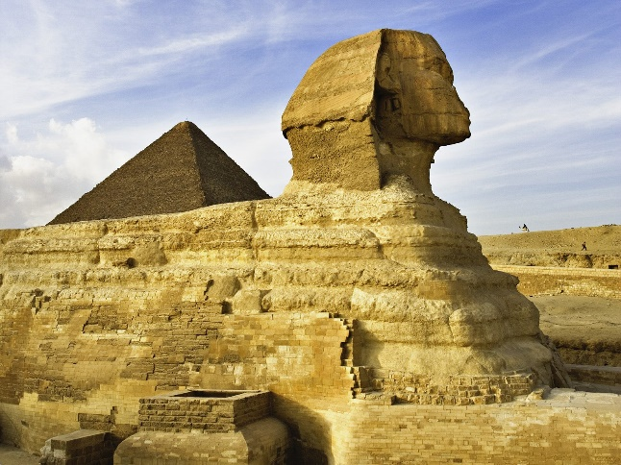
THE GREAT SPHINX

One of the great marvels of the ancient and modern world is the GREAT PYRAMID OF Geza. It is the only survivor of the famed “Eight Wonders of the World” This massive mountain of stone, considered the king of buildings, and is an architectural wonder which still perplexes modern technological engineering and science.
Almost as a guardian to the mystic secrets housed in the GREAT PYRAMID, sits the imposing figure of the sphinx. It is a gigantic figure of a black man carved out of solid stone, with a LION’S body. These incredible marvels of the ancient BLACK WORLD so upset the French conqueror Napoleon, that he ordered the Sphinx defaced by having its broad, flat nose shot off for target practice.
Why are whites so anxious to erase our glorious history?

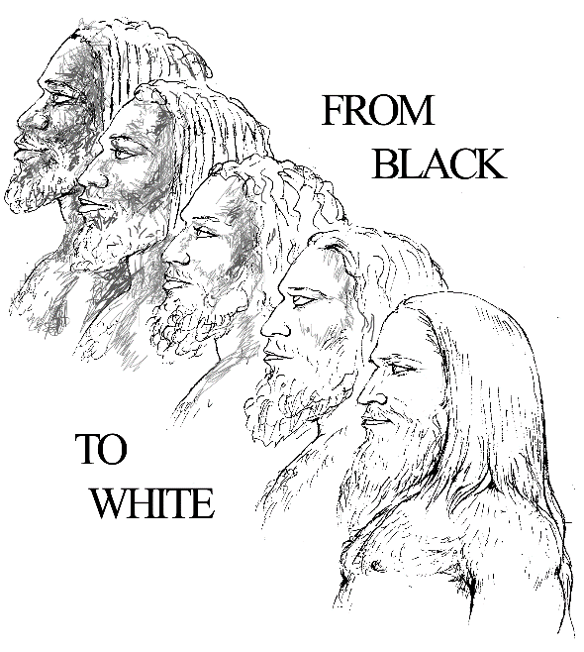

SCIENTIFIC FACTS

It is a known scientific genetic fact that if you begin with an original WHITE (Adamic) Race, there doesn’t exist the genetic possibility of producing the other races, including the black race. However if you begin with an original BLACK (Adamic) RACE, all the variety of complex races, including the white race can be produced.

NOTE: WHITE SKIN is a biological mutation derived from one of three sources LEPROSY, ALBINISM, or SELECTIVE ADAPTION to adversely cold climates as is common to European, Northern Asian countries occupied by the sons of Japheth.

It is not only a biological but an archaeological fact, that the first man (Adam) was of BLACK ORIGIN, and that civilization evolved from the Fertile Crescent in Northeast Africa (Eden), in a climate suitable for human agricultural growth and development.

Archeologists have published conclusive evidence, based on their archeological finds in Africa that the first man (Adamic race) evolved from Africa and was of African stock.
Modern Scientific tracking finally verifies through genetic DNA research that the modern human race that all 7 billion are genetically traced to one common mother, a Black woman that lived in Africa they named Lucy. Lucy is very close to the biblical Eve who is called the mother of all living.

PART III
THE GREAT CHALLENGE

If we are to believe the Holy Bible to be the inerrant WORD of our Creator, then we must conclude that the Ancient Israelites were a DARK SKINNED WOOLY HAIRED Semitic race of people and their descendants, wherever they are today, are still a dark skinned (BLACK), wooly haired Semitic people.
These facts are so overwhelmingly evident in scripture, that we offer the challenge of an open debate to any so-called Jewish or professing Christian scholar, to produce one, just one scripture which can show the ancient Hebrew Israelites to be WHITE, or their Messiah in the flesh to be WHITE, as these IMPOSTERS and LIARS claim.
BIBLICAL PROOF
1 Kings 18:24 Call ye on the NAME of your Gods (Baal, called Lord Je-Zeus today), and I will call on the NAME OF YAH (according to HIS SAVING WORD!): and the EL that answereth by FIRE (TRUTH!), let Him be Elohim. And all the people answered and said, it is well spoken.

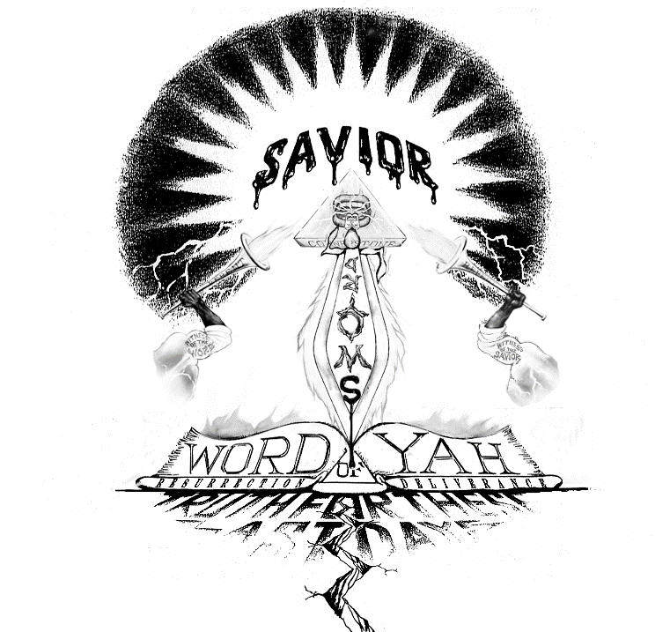

WE ARE NOT RACISTS
It is not our purpose to put down white people or any race of people, but rather to prove beyond a shadow of a doubt, that the so-called Negro is in FACT, the Lost Sheep of the House of Israel.
We know that there will be those who will say, “It doesn’t matter what color He was.” We would remind these people that it is not us they should make this FACT known to, but to those who have DECEIVED THE WHOLE WORLD, by pouring billions of dollars, for over hundreds of years, in an all out effort to circulate through idols, paintings, books, movies, and television, etc. depicting our SAVIOR as a white man with blond hair and blue eyes. This is in effect Satans’ GREAT WHITE LIE!
Satan would love to label us, the true persecuted worshippers of YAH, in His Savior (HIS WORD!), a CULT, or RACISTS, for not only championing the cause of the so-called Negro, and reclaiming what he has STOLEN from us…OUR TRUE IDENTITY!
We liken this to the WOLF, calling the sheep a RACIST, because he snatched the wolf’s SHEEP CLOTHING off, exposing him to be the IMPOSTER he is.
Let me state right here, for the record, that we are NOT RACIST! The truth is, I would consider a white person, or a person of any race, more of a brother than my own flesh and blood mother, brother, and sister (whom I love), if they possess the HOLY SPIRIT (the SPIRIT of THE WORD of YAH…IN TRUTH!)
Matthew 12:50 For whosoever shall do the will (WORD) of My Father which is in heaven, the same is My brother, and sister, and mother (TRUE! [WORD TO HEART, DIE TO SELF] Born Again , Spiritual Family!).
I would even consider such a person of any race, more my Spiritual brother than those of my own Hebrew brothers and sisters in the flesh, who persist in walking in rebellion to His blessed WORD! …and SAVIOR!
It’s not that we don’t love our people. We love them with the greatest love, for it is written, “Greater love hath no man than this, that a man lay down his life for his friends.” (John 15:13) We willingly put our lives in jeopardy to bring you these great truths, which are so hated by Satan and his ministers. We deeply love our people and it hurts us greatly to see us in our present wretched, ignorant condition caused by SATAN’S LIES. But our greatest love remains His blessed WORD, OUR SAVOIR! If it is that we are to be hated and falsely accused, let the truth be known. It is for the TRUTH (THE WORD of YAH), His Name sake, our greatest love, that we suffer these abuses. Counting it all as joy, that we were found worthy to suffer for His Name’s (TRUTH!) sake.
Too many of our people stumble over reverse racism, making hatred of white people and their BLACKNESS their righteousness. If we assume this attitude, are we any better than they? Our standard of righteousness should be the Father and His HOLY WORD…NOT BLACKNESS!
BIBLICAL PROOF

Genesis 17:1 I AM EL-SHADDAI (THE ALMIGHTY!); walk before Me, and be thou PERFECT.

Deuteronomy 10:17, 19 For YAH your Elohim is EL of El’s and RULER of rulers, a GREAT EL, MIGHTY, and TERRIBLE, which regardeth not persons (NO RESPECT OF PERSONS), nor taketh bribes.
He doth execute the judgment of the fatherless and the widow, and loveth the STRANGER (GENTILES), in giving him food and raiment.

Love ye therefore the STRANGER (GENTILES): for ye were (are today) strangers in the (SECOND) Egypt (America). Deuteronomy 28:68

Truly YAH is not a respecter of persons (Acts 10:34).He shall judge every man (Black, Brown, Red, Yellow, and White), according to his WORD, and every man according to his WORKS (Revelation 2:12). Amen

PART IV
THE AWESOME POWER OF IMAGING!

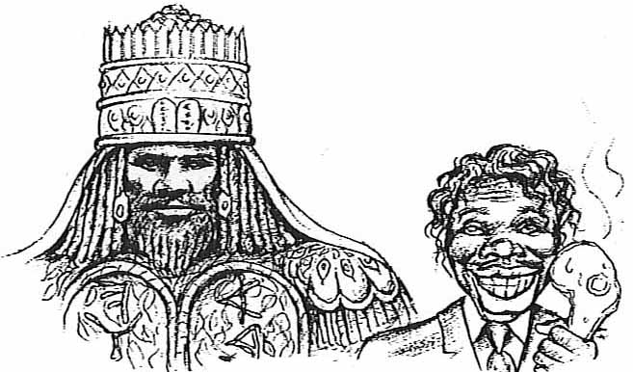

FROM FIRST TO LAST
To many of our readers, the fact that the Bible itself proves beyond a shadow of a doubt over and over again, that the ancient ISRAELITES were BLACK PEOPLE with WOOLY HAIR comes as a complete revelation. Others, on the other hand may have long been aware of these facts. Either way now knowing this to be true, the question naturally arises, how could a people so high in ancient times fall so very low today?
The KEY to our answering this question is locked in our ability to understand the awesome power of IMAGING! It is this knowledge (Power of Imaging) which our enemies have skillfully mastered to perfection to literally program an entire race to SELF (Hatred) DESTRUCT!
From the time you’re born until the day you die, you are bombarded daily with images that ultimately formulate who you are and how you perceive the world around you.
Through the power of IMAGING, the power to control the images (television, movies, books, paintings, music, etc.,) a people consume, you can ultimately create invisible bonds stronger than the strongest chain.

It is a fact that man is a mental being. If you can create the image in a people’s mind that they are inferior, you don’t have to keep them in chains. Their own sense of inferiority will keep them from rising above the low mental image they have of themselves.

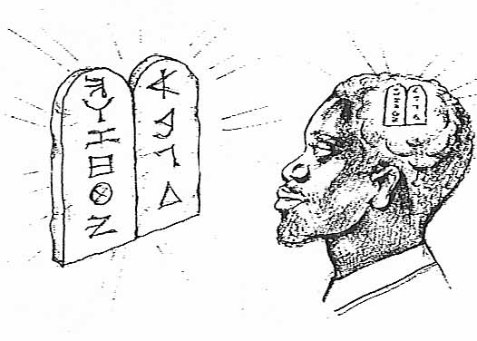
Even if a people were descended from African royalty so great the European world elevate their ancestors to the level of Gods, if the descendants of that same people were IGNORANT of their glorious ancient history they could find themselves reduced to the lowest of all people on earth today. Simply for this lack of knowledge… “My people are DESTROYED for a LACK of KNOWLEDGE (of SELF!).” Hosea 4:6

THE AWESOME POWER OF IMAGING

Ever heard the saying “You are what you think?” Well this is true, and the Bible states it like this: “For as a man thinketh (IMAGES!) in his heart (MIND), so is he.” Proverbs 23:7

Our Creator knew this awesome power of IMAGING, when he commanded us “NOT to make any GRAVEN IMAGES to bow down and worship.”

Exodus 20:4, 5 Thou shalt NOT MAKE unto thee any GRAVEN IMAGE, or any LIKENESS of any thing that is in Heaven above, or that is in the earth beneath, or that is in the water under the earth. Thou shalt not BOW DOWN (image) thyself to them, nor serve them (following man made Holidays): for I YAH thy Elohim am a JEALOUS Elohim, visiting the iniquity of the fathers upon the children unto the third and fourth generation of them that hate Me: And showing mercy unto thousands of them that love Me, and keep My Commandments.

He warned us against worshiping false image because He created our minds to be in His DIVINE (MIND!) IMAGE, the IMAGE of HIS WORD. “…and the WORD was YAH.” John 1:1
Notice carefully how in the following scriptures YAH places great importance in us PROGRAMMING (IMAGING) HIS WORD! Into our MINDS!
Deuteronomy 6:4, 9 Hear O Israel: YAH our Elohim is ONE (ONE WORD!):
And thou shalt LOVE YAH thou Elohim with ALL THINE HEART, and with ALL THINE SOUL, and ALL THY MIGHT.
And these WORDS, which I command thee this day ( the Ten Commandments) shall be in thine HEART: (HOW?)
And thou shalt TEACH them DILEGENTLY unto thy children, and shalt TALK OF THEM when thou sittest in thine house, an when thou walkest by the way , and when thou liest down, and when thou risest up. (WORD IMAGING).
And thou shalt BIND them for a SIGN upon thine HAND, and they shall be as FRONTLETS between thin EYES. (WORD IMAGING).
And thou shalt WRITE then upon the post of thy HOUSE, and on thy GATES, (WORD IMAGING).
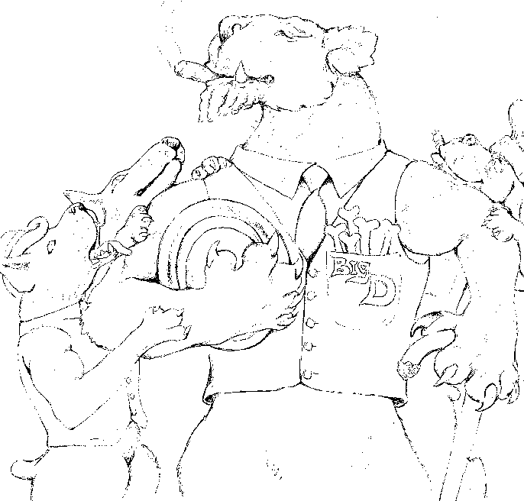

the “BIG DOG!”
To fully realize the awesome POWER of IMAGING, let me just give an illustration of a cartoon taken from Royal House Ink’s parable “The Real King of the Jungle”, where Prince Ariyah a little Lamb Lion King was broken down and transformed into a dog. Under this unnatural condition the Lion’s ROLE MODELS (IMAGING) were Dog’s, so although he as born to be King of the Jungle, in his MIND he was a DOG!

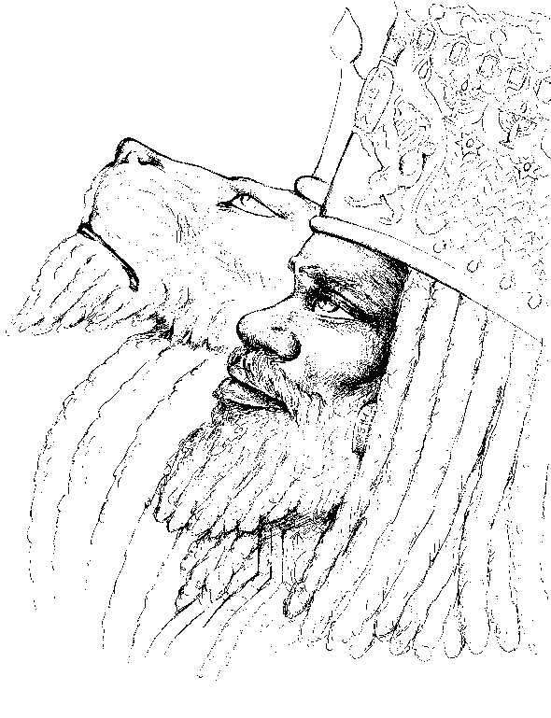

SEED OF DAVID, TRIBE OF JUDAH
LAMB LION KING
So he went around cowering and stooping to Master like a dumb Dog, only felling he was worthy to get the crumbs off the Master’s table. So he grew up with a low self-esteem, feeling incompetent and inferior to the other sheep (sound familiar?). One day he was SHOCKED! To the reality of his TRUE KINGLY IDENTITY, when he woke up to what the Master truly thought about him… He woke up to facts that his ROOTS and his DESTINY where in HIS Fathers’ ancient Homeland. To get there he had to have the Heart of a Lion to stand and fight against his enemies and reclaim his Fathers’ Throne as the REAL King of the Jungle. He that was once despised was now lifted up in glory. This story beautifully illustrates the power of IMAGING. And it also shows how the once great royal BLACK HEBREW tribe of Israel, could fall to become the accursed ignorant so-called Negro, the scourge of the earth today.
For hundreds even thousands of years now, men have studied the effect of IMPRINTING (IMAGING!) their culture over a conquered people. For example in the APOCRYPHA books, found in the Jerusalem or Catholic Bibles, in the first books of the Maccabees, we can study the effect the GREEK Kingdom, which ruled at that time, had over our ancient African Hebrew forefathers.
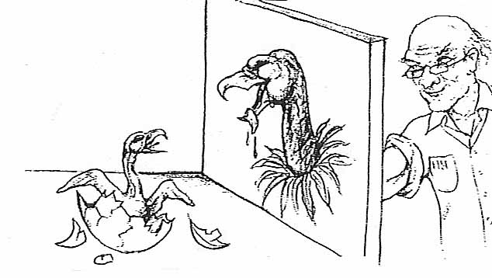
I Maccabees 1:11, 15 In those days (137th year of the Kingdom of the GREEKS) went there out of Israel (BLACK ISRAELITES) wicked men, who PERSUADED MANY, saying, Let us go and make a COVENANT with the HEATHEN (Greeks) that are round about us: for since we departed from them we have had much sorrow. So this DEVICE pleased them well. Then certain of the (Hebrew) people were so forward herein, that they went to the King Antiochus, who gave them LISCENCE to do after the ORDINANCES (Sunday, Christmas, Easter, etc.) of the HEATHEN. they made themselves UNCIRCUMCISED, and forsook the HOLY COVENANT and ...JOINED THEMSELVES (became NEGRO GREEKS) to the HEATHEN, and SOLD (their souls) to do mischief.
SCIENCE OF IMPRINTING

Today they have gotten MENTAL GENOCIDE (to kill an individual’s ethnic, cultural, and racial identity) through IMAGING, down to a precise SCIENCE. Science knows now that when animals are taken from their natural surroundings at a very early age, and raised (IMAGED) by man, that those animals will eventually believe (in their MIND!) that they are human. And as such would be totally unable to function, reproduce, or survive when reintroduce into their native environment without the aid of their human masters.
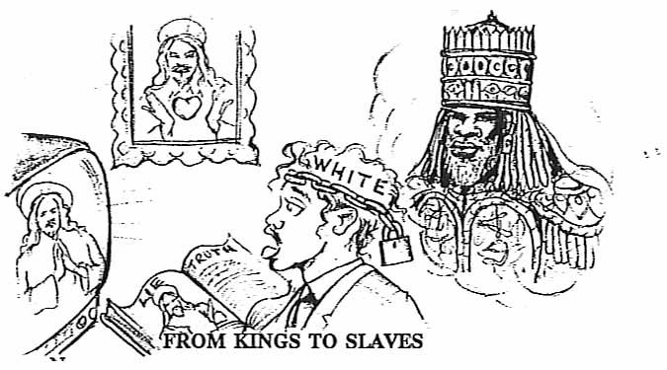
For example, take the case of the Condor. Because this bird is on the brink of extinction their eggs are carefully collected and artificially hatched. As a result of their experience the baby Condors are only handled and fed by men

using Condor looking gloves being careful to always remain hidden behind blinds. This is done do so the bird will not be imprint (imaged) by humans. In this way they hope to one day reintroduce the Condor back into its native environment.
Seeing the pain science goes to preserve the life of a buzzard, is it any accident that we have been bombarded by the false white image of Je-Zeus (Jesus) to look up to as God? (Make no GRAVEN IMAGE!
Now you can begin to see how a person could be of royal African blood, the descendent of ancient Kings, from a Holy and Priestly Nation, yet his descendent could wind up being an ignorant, European minded, pig eating slave. Just steal the descendent of that African king. Raise him in a predominantly white culture where all of his positive role models (Imaging) are white. And teach him the lie that his forefathers back in Africa were naked savages running around in feathers, and that the great white father did him a favor by stealing him from his land and making him a slave, to give him religion and civilization. Why that poor soul would always be chained to a subservient position in life by the negative FALSE IMAGE of HIMSELF, his CREATOR, and his AFRICAN HISTORY, because of the unconscious (subliminal) worship he would now have of the WHITE SLAVE MASTER, his WHITE GOD, and his (WHITE WASHED) HISTORY
Such a person would qualify as being SICK (mentally), LEPROUS (white minded), DEAD (spiritually) and totally POSSESSED (held captive) to SATANIC LIES! This is the sorry condition of the so-called NEGRO, the LOST SHEEP of the House of Israel today. If any other on earth had undergone the BRAIN WAHSING we’ve endured for the past 400 years, they too would be LOST!
We were stolen from our LAND (Israel, North-East Africa) and brought in chains to “the land of the free,” where we were given a WHITE IDOL to hang in our homes, and taught this white man was “God made flesh.” If this were not bad enough, we were taught to observe Pagan Holidays, where for example, we were taught to bring our children at a very early age, ( while their little minds are very impressionable) to the GREAT WHITE FATHER (Satan Claws) seated in a GOLDEN THRONE in a magical setting, surrounded by bright lights and cameras, where we then were taught to (offer them up to Satan) sit our children (innocent victims) on his fat lap an teach them the “LIE,” to believe the toys we had worked so hard to pay for, were magically provided by the GREAT WHITE FATHER if they were good boys and girls.
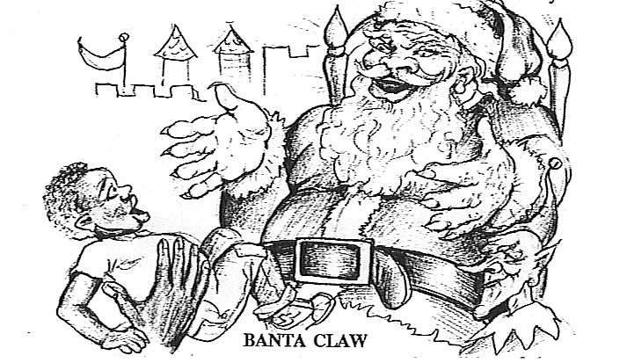
If you think I'm exaggerating the mental condition of the so called Negro, just think of it this way. Do you think Europeans would hang a picture of a BLACK MAN (though the Messiah was a BLACK MAN) in their houses teaching their children this is their Savior? Or for example, do you really think they would put their children in the lap of an old fat black African named, let’s call him “Bantu Claws”, and teach them that he made their toys in a magic hut, deep in the heart of the Congo, where once a year with his pigmy helpers in a chariot pulled by twelve flying zebras, he would visit them leaving gifts under their magic tree?
And if they refused to go broke celebrating this man made foolishness, under the guise of the birthday, of the baby SUN GOD, he would be branded worse than a heretic...a SCROOGE! Do you think good old white folks would go for it? They would have to be out of their MINDS... like the so-called Negro, to subject themselves and their families to such MADNESS. And we have the nerve to wonder why nobody respects us as a people?
If you do nothing else from reading this article, TEAR DOWN the WHITE IDOLS off your WALLS, out of your BOOKS, out of your MINDS! In their place put up your Creator’s Ten Commandments in your house and His Holy WORD in your HEART. Keep faithfully His WORD, drilling it in your children, along with their glorious HISTORY, found in the HOLY BIBLE, and the promises to take away the CURSE, and bless you with the HEALTH, WEALTH, and WISDOM we possessed in ancient times. And in the faith of YAHSHUA (the TRUE WORD made FLESH!)...ETERNAL LIFE. (HalleluYAH!).

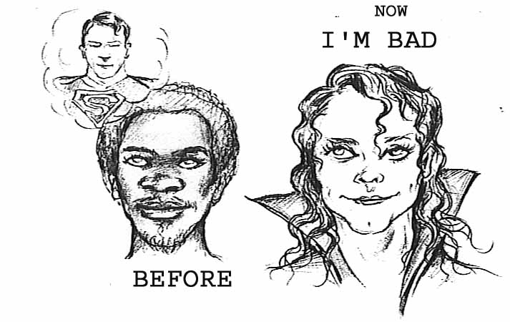
THE LIVING DEAD (RACE)
(MENTAL GENOCIDE)

We have already proved how a beautiful original African man, with prominent Semitic features of dark skin, wool hair, large nose and thick lips, can be raised without knowledge of himself in a predominantly European land, where all the positive ROLE MODELS have WHITE SKIN, BLUE EYES, STRAIGHT HAIR, THIN NOSE, and LIPS. He would grow up with a negative inferior, SELF IMAGE (self hatred).
This is the highest form of GENOCIDE (extermination of a people) practiced today. Understand, without the use of a conventional weapon, but through television, movies, records, books, etc., and the awesome power of IMAGING, you could exterminate a RACE. Let me explain.
Through the power to project Hebrew in subservient roles as pimps, prostitutes, uncle Toms, lazy, irresponsible, etc., while on the other hand projecting Europeans as the great white fathers and mothers knowledgeable, strong, responsible, wealthy, powerful, etc., results in many so-called Negroes becoming so MENTALLY ILL (self hatred), they actually buy blue contact lenses, bleach their skin, have plastic surgery performed on their nose or lips, and straighten or curl their hair, so as to conform to the EUROPEAN IMAGE PROGRAMMED into their (WHITE) MINDS. In turn these mentally sick (white minded) Negroes are often rewarded by being SET UP, as the ROLE MODELS for our people, thus perpetuating the inferior mental image to our race.
Such a person is in all actuality the walking DEAD, having been culturally and ethnically MURDERED. They are no longer BLACK or WHITE, but what use to be called OREOS. They were originally black on the outside, but are now white (minded) on the inside. Such persons, though set up to be surrounded by white people, who cuddle and adore them, like people pamper their dogs or their dolls. Because these oreo house Negroes have sold their souls (blackness) and manhood (Homosexuals) for their wealth and fame, these sick puppets are given the best houses and cars, and are allowed to live among and inter-marry with their white masters. They become so sick they will actually feel uncomfortable or threatened around their own people.
But a natural BLACK MAN in the DIVINE IMAGE of YAH Elohim his Creator, with wooly dread locks and beard, who believes in YAH’S WORD and know His ancient Royal HEBREW CULTURE and HISTORY, is feared and hated by whites; though he would be the closest visual IMAGE of what the MESSIAH truly looked like in the FLESH! Whom they claim to love so much. The self awareso called black is so hated that the FBI under the Trump Administration has labeled them the #1 Terrorist threat in the Nation through their creation of the new broad classification called Black Identity Extremist (B.I.E.).

PART V
SOLUTION
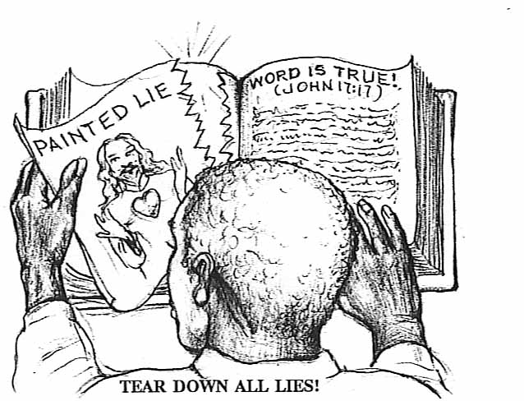
We opened this chapter revealing the conspiracy on the part of Europeans to WHITE-WASH history, by painting the Messiah and all of the ancient BLACK biblical forefathers as WHITE.

TEAR DOWN ALL LIES!

We must tear down all of the false WHITE IDOL (JeZeus) gods used to BRAIN WASH us, from off our walls, from out of our Bibles, and from out of our MINDS!
Now please understand to replace it with some BLACK IDOL would be no better. “Thou shalt not make unto thee any GRAVEN IMAGE, or any LIKENESS of anything that is in Heaven above, or that is in the earth beneath, or that is in the water under the earth; thou SHALT NOT BOW DOWN thyself unto them, NOR SERVE them: ”Exodus 20:4,5

THE WORD MADE FLESH!

YAHSHUA being THE WORD of YAH! made flesh, should always be depicted as THE WORD (Bible) in a man’s body. No face should ever be shown, so we don’t focus on the man, but rather THE WORD. If He is depicted as THE WORD made FLESH, it is important to know the Bible teaches that HOLY FLESH was a DARK –SKINNED and WOOLY-HEADED race, but more importantly, He was THE WORD of YAH...OUR SAVIOR! …“the FLESH profiteth NOTHING! The WORDS that I speak unto you, they (THE WORDS!) are SPIRIT, and they (THE WORDS!) are LIFE! John 6:63

PAINT THE TRUTH!
We all (whites and blacks) must demand that publishing companies and Bible book stores be more responsible in publishing Biblical literature accurately depicting the ancient Biblical fathers as people of color with wooly hair, as the Bible itself witnesses. This is their chance to show the world they are NOT RACISTS, but are genuinely concerned with accurate portrayals in their publications.
For example, as we have already seen, the Bible teaches Adam was made from “the dust of the GROUND,” Gen. 2:7, The ancient Israelites were compared to the African Ethiopians (Amos 9:7), and let’s not forget that our Creator (Dan. 7:9) and His Son were described as having PURE WOOLY HAIR (Rev.1:14). And finally that they wore their WOOLY HAIR in ancient times in LOCKS (Num. 6:5, Judges 16:13, etc.) called today DREAD LOCKS.
With this overwhelming wealth of evidence revealed in scripture, artists should depict the ancient Biblical characters with an EARTHLY (red, brown, black…but NOT WHITE!) complexion, with long WOOLY HAIR. It’s that simple. That would be a more truthful rendering of the ancients, and we know they (Good Christians as they are) would want to present the TRUTH and would never represent a Obvious LIE!
Now if they should refuse to acknowledge the truth, don’t take up the SWORD and go to WAR, just pick up the PEN or BRUSH and begin to PAINT THE TRUTH yourself. Remember if paintings of LIES have deceived the world, TRUE DEPICTIONS can FREE OUR MINDS!
For the publications and books we already own, a simple investment in a brown or black marker pen can work miracles to correct all of the misrepresentations, by simply coloring their white faces and bodies BLACK. You should never show your children a picture of one of the Biblical Hebrews depicted as WHITE. That would be teaching them a LIE! (The truth is, the ancient European Greeks, and Romans who conquered the world turned the ancient black images WHITE under their authority).
Finally there exists a vast virgin untapped field to reach thousands of brain washed minds, via the movie and video industry. Some enterprising young producer can make millions on a well-executed movie utilizing an all-black cast to play Moses, David, Solomon, Daniel, etc. make a True ancient Bible epic.
In this, and in many other ways, we can begin to teach our Royal History in the TRUE IMAGES our children, our people can again benefit from.
“Know the Truth and Truth shall make you FREE!
YAH’S WORD IS THE ROCK!

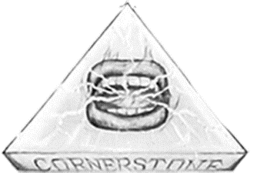

WORD OF YAH…THE CORNERSTONE!

Psalms 118:22 The STONE (THE WORD!) which the BUILDERS (true black Israel) refused is become the HEAD STONE (SAVIOR WORD Of YAH) of the CORNER (WORD OF YAH IS KING of KINGS of the HOUSE of Israel!)

HOUSE BUILT ON THE FOUNDATION
OF THE APOSTLES AND THE PROPHETS!

Ephesians 2:20 And (believers) are built upon the FOUNDATION of the APOSTLES (eyewitness) and the PROPHETS (prophecy), the SAVIOR HIMSELF being the CHIEF CORNER STONE (SAVIOR WORD OF YAH!);
YAH’S WORD IS THE SOLID ROCK FOUNDATION!
Matthew 7:24,25 Therefore whosoever (everyone) HEARETH these sayings (WORDS) of Mine (the SAVIOR), and DOETH them (THE WORDS), I will liken him unto a wise man, which built his house upon a ROCK (THE WORD OF YAH!):
And the rain (JUDGEMENT!) descended, and the floods (PERSECUTIONS!) came, and the winds blew (GREAT TRIBULATIONS!), and beat upon that HOUSE (that person); and it FELL NOT!: for it (HE) was founded upon a ROCK (THE WORD OF YAH!).
WORD OF YAH IS THE STONE!

Daniel 2:34-36 Thou sawest till that a STONE (WORD OF YAH) was cut out without hands, which smote the image upon his feet (the SYSTEM called the BEAST, the LAST GENTILE GLOBAL WORLD EMPIRE, Rev.13, Rev.19) that were of iron and clay, and brake them to pieces.
Then was the iron, the clay, the brass, the silver, and the gold, broken to pieces together, and became like the chaff of the summer threshing floors; and the wind carried them away, that no place was found for them: and the STONE (The WORD OF YAH) that smote the IMAGE (GENTILE MAN MADE IDOL) became a GREAT MOUNTAIN (YAH’S KINGDOM!), and filled the whole earth.
THE SAVIOR WORD OF YAH IS TO RETURN FROM HEAVEN AND ESTABLISH HIS KINGDOM!
Acts 1:9-11 And when he had spoken these things, while they (the DISCIPLES) beheld, He (the SAVIOR) was taken up; and a CLOUD received Him out of their sight.
And while they looked stedfastly toward heaven as he went up, behold, two men stood by them in white apparel (TWO WITNESSES);
Which also said, Ye men of Galilee, why stand ye gazing up into heaven? this same SAVIOR, which is taken up from you into heaven, shall so come in LIKE MANNER (VISIBLY) as ye have seen him (VISIBLY) go into heaven.
”He that has ears to HEAR (UNDERSTAND!), let him HEAR (UNDERSTAND!).”
“MY SHEEP HEAR (UNDERSTAND) MY VOICE, (Their SAVIOR WORD OF YAH!)”

